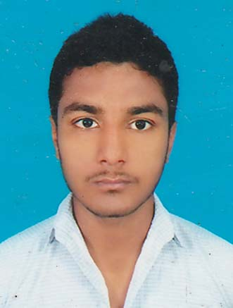
NAME: SUMIT DAS

dassumitkalna@gmail.com
09679072042

CAREER OBJECTIVE:

Hard working and ambitious, I have always strived for the best, considering my experience, ideas and talent, I would like to be a part of the organization and put in my best efforts for the overall growth of the organization.

EDUCATIONAL QUALIFICATIONS:

S.L. No. | Examination Passed | Year of  Passing | Board / University | % of Marks
1. | M.P | 2011 | W.B.B.S.E | 60%
2. | H.S | 2013 | W.B.C.H.S.E | 62.6%
3. | B.A | CONDUCTING B.A 3rd YEAR | BURDWAN UNIVERSITY | RESULT PENDING AT B.A 3rd YEAR

PROFEESIONAL PROFICIENCY:

- DIPLOMA IN COMPUTER APPLICATION.

- WINDOWS .
- DOS.
- MS - OFFICE - 2003
- INTERNET.
- MS - EXCEL.

- VOCATIONAL EDUCATION & TRAINING IN ENGINEERING & TECHNOLOGY.

- CONSUMER & INDUSTRIAL ELECTRONICS MECHANICS.
- MONOCHROME (B & W) & COLOUR T.V MECHANIC.

- APPRECIATION OF DIGITAL LITERACY.

1. NATIONAL DIGITAL LITERACY MISSION.
2. ELECTRONICS & INFORMATION TECHNOLOGY.

- DIPLOMA IN TALLY (9.0)

Personal profile:

FATHER's NAME : SANKAR DAS
GENDER : MALE
DATE OF BIRTH : 28.09.1995

MARITAL STATUS : UNMARRIED
LANGUAGE KNOWN : BENGALI, HINDI & ENGLISH
VILL + P.O : KRISHNADEVPUR (GOSAI PARA)
P.S : KALNA

DIST : BURDWAN
STATE : WEST BENGAL
PIN : 713405
I hereby declare that the statements are made in this application are true, complete and correct to be best of my knowledge and belief.

Place: KALNA
Date: ……………………………………
SIGNATURE

